UCS 1602 - Compiler Design

**Assignment-4**

Recursive Descent Parser Using C

**Swetha Saseendran**

**CSE-C**

**185001183**

**Aim:**

Write a program in C to construct Recursive Descent Parser for the following grammar which is for arithmetic expression involving + and *. Check the Grammar for left recursion and convert into suitable for this parser. Write recursive functions for every non-terminal. Call the function for start symbol of the Grammar in main().

G: E->E+T|T

T->T*F | F

F->i

Extend this parser to include division, subtraction and parenthesis operators

G: E->E+T|E-T|T

T->T*F | T/F|F

F->(E)|i

**Code: Grammar 1**

#include<stdio.h>

#include<string.h>

#include<stdlib.h>

/* STRUCTUERE */

typedef struct

{

    char ip[100];

    int n;

}input;

/* FUNCTIONS */

void E(input *in);

void T(input *in);

void Tprime(input *in);

void Eprime(input *in);

void F(input *in);

/* DEFINED FUNCTIONS */

void E(input *in)

{

  T(in);

  Eprime(in);

}

void Eprime(input *in)

{

  if(in->ip[in->n]=='+')

  {

    (in->n)++;

      T(in);

      Eprime(in);

  }

  else

    return;

}

void T(input *in)

{

  F(in);

  Tprime(in);

}

void Tprime(input *in)

{

  if(in->ip[in->n]=='*')

  {

    (in->n)++;

      F(in);

      Tprime(in);

  }

  else

    return;

}

void F(input *in)

{

    if(in->ip[in->n]=='i' && in->ip[in->n+1]=='d')

    {

        (in->n)+=2;

        if(in->n==strlen(in->ip))

        {

        printf("Parsing Complete string accepted\n");

        exit(0);

        }

    }

    else

    {

        printf("Parsing error: String not accepted\n");

        exit(0);

    }

}

/* MAIN FUNCTION */

int main()

{

  input *in = malloc(sizeof(input));

  printf("Enter the String to be parsed: ");

  scanf("%s",in->ip);

  in->n = 0;

  E(in);

  if(in->n!=strlen(in->ip))

    printf("Parser Error : String not accepted\n");

}

**OUTPUT:**

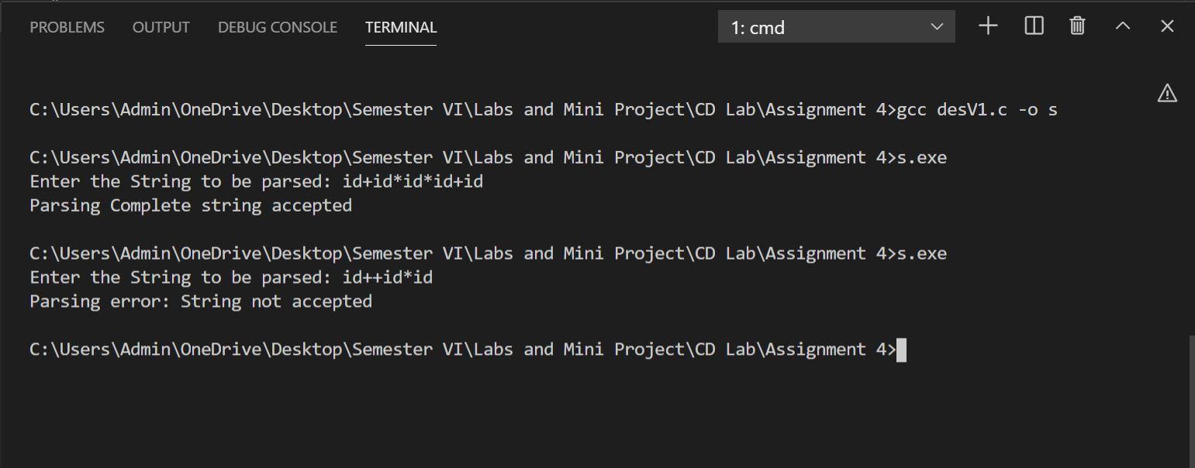

**Code: Grammar 2**

#include<stdio.h>

#include<string.h>

#include<stdlib.h>

/* STRUCTUERE */

typedef struct

{

    char ip[100];

    int n;

}input;

/* FUNCTIONS */

void E(input *in);

void T(input *in);

void Tprime(input *in);

void Eprime(input *in);

void F(input *in);

/* DEFINED FUNCTIONS */

void E(input *in)

{

  T(in);

  Eprime(in);

}

void Eprime(input *in)

{

  if(in->ip[in->n]=='+')

  {

    (in->n)++;

      T(in);

      Eprime(in);

  }

  else if(in->ip[in->n]=='-')

  {

    (in->n)++;

      T(in);

      Eprime(in);

  }

  else

    return;

}

void T(input *in)

{

  F(in);

  Tprime(in);

}

void Tprime(input *in)

{

  if(in->ip[in->n]=='*')

  {

    (in->n)++;

      F(in);

      Tprime(in);

  }

  else if(in->ip[in->n]=='/')

  {

    (in->n)++;

      F(in);

      Tprime(in);

  }

  else

    return;

}

void F(input *in)

{

    if(in->ip[in->n]=='(')

    {

        (in->n)++;

        E(in);

        if(in->ip[in->n]==')')

        {

            (in->n)++;

            if(in->n==strlen(in->ip))

            {

                printf("Parsing Complete string accepted\n");

                exit(0);

            }

        }

    }

    else if(in->ip[in->n]=='i' && in->ip[in->n+1]=='d')

    {

        (in->n)+=2;

        if(in->n==strlen(in->ip))

        {

        printf("Parsing Complete string accepted\n");

        exit(0);

        }

    }

    else

    {

        printf("Parsing error: String not accepted\n");

        exit(0);

    }

}

/* MAIN FUNCTION */

int main()

{

  input *in = malloc(sizeof(input));

  printf("Enter the String to be parsed: ");

  scanf("%s",in->ip);

  in->n = 0;

  E(in);

  if(in->n!=strlen(in->ip))

    printf("Parser Error : String not accepted\n");

}

**OUTPUT:**

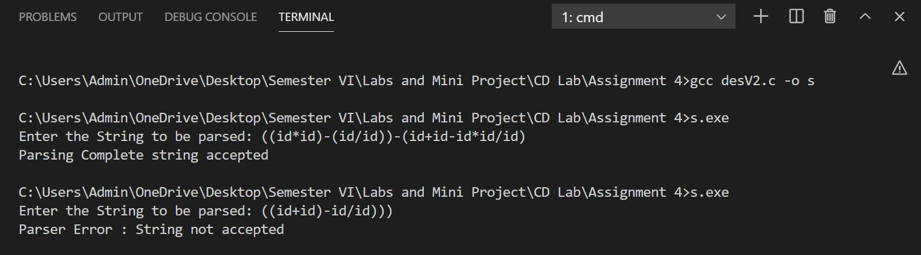

**LEARNING OUTCOME:**

* Understood about the working of a Recursive Descent Parser,

that the Recursive Descent Parser, being a Top-Down Parser, does not work with Left-Recursive Grammars.

* Understood the need for this type of conversion, as top-down parsers cannot handle left recursive grammars.
* Learnt to describe how automated scanner generators construct a finite automation from regular expression.
* Learnt to select and use appropriate data types and data structures to solve problems.
* Strengthened my knowledge and skills in string operations and to parse each production in input to check if its belongs to the grammar or not.
* Learnt to modularise long code into functions and follow the best practices.

**RESULT:**

Successfully implemented the code to construct Recursive Descent Parser for the given grammars.